MAGNETO-OPTICAL STRUCTURE OF THE NICA COLLIDER WITH HIGH CRITICAL ENERGY

S. Kolokolchikov, Yu. Senichev, INR RAS, Moscow, Russia  
E. Syresin, JINR, Dubna, Russia

Abstract

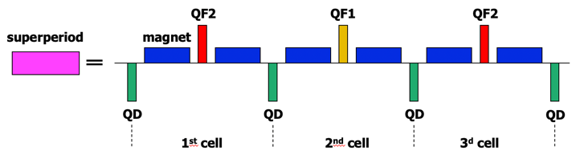For proton option of NICA collider, it is necessary to cross the transition energy ($γ_{tr}=7,1$). For this reason, a magneto-optical structure with a high critical energy ($γ_{tr}=15$) is considered. In this case, methods of increasing the critical energy for the proton option of the NICA collider are investigated. The method of superperiodic modulation of quadrupole gradients is applied. The selection of sextupoles is carried out to suppress the natural chromaticity and compensate the sextupole component. The Twiss parameters for the proposed structures are given, as well as the dynamic apertures and working points are investigated.

Superperiodic Modulation

The momentum compaction factor is defined in general as

$α=\frac{1}{γ_{tr}}=\frac{1}{C}\int_{0}^{C}{ }\frac{D(s)}{ρ(s)}ds$ (1)

where $C$– the length of a closed equilibrium orbit, $D(s)$– horizontal dispersion function, $ρ(s)$– radius of curvature of the equilibrium orbit. And taking into account equation for dispersion function with biperiodic focusing:

$\frac{d^{2}D}{ds^{2}}+[K(s)+εk(s)]D=\frac{1}{ρ(s)}$ (2)

where $K\left(s\right)=\frac{e}{p}G\left(s\right)$, $εk\left(s\right)=\frac{e}{p}ΔG\left(s\right)$, $G\left(s\right)$– gradient of magneto-optical lenses, $ΔG\left(s\right)$– superperiodic gradient modulation. Thus, MCF depend on the functions: the curvature of the orbit $ρ(s)$, gradient and modulation of quadrupole lenses respectively $G\left(s\right)$, $ΔG\left(s\right)$.

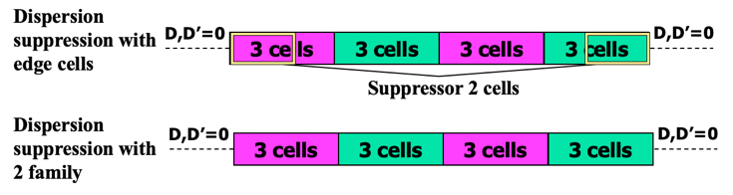In the NICA structure, the regular arrangement of dipole magnets eliminates the possibility of modulating the curvature of the orbit. Therefore, to change transition energy use only the modulation of dispersion function by modulating the strength of quadrupole lenses over the superperiod. For one superperiod, the MCF is determined [1]:

$α_{s}=\frac{1}{ν_{x,\text{ arc }}^{2}}\left\{1+\frac{1}{4}{\left(\frac{{\overline{R}}_{\text{arc }}}{ν_{x,\text{ apk }}}\right)}^{4}\sum_{k=-∞}^{∞}{ }\frac{{g_{k}}^{2}}{\left(1-\frac{kS}{ν_{x,\text{ arc }}}\right){\left[1-{\left(1-\frac{kS}{ν_{x,\text{ arc }}}\right)}^{2}\right]}^{2}}…\right\}$ (3)

where ${\overline{R}}_{arc}$– the average value of the curvature, $ν_{x,arc}$– the number of horizontal betatron oscillations on the length of the arc, S – number of superperiods per arc length, $g_{k}$– $k$-th harmonic of the gradient modulation in the Fourier series expansion of the function $εk\left(s\right)=\sum_{k=0}^{∞}{g_{k}}cos(kϕ)$. First harmonic $k=1$ has a dominant influence and for 12 FODO cells, the condition is implemented $S=4$, $ν_{x,арк}=3$, where 3 FODO cells are combined into one superperiod as shown on Figure 1. Thus, due to the tune of betatron oscillations of a multiple of 2π, the arc has the properties of a first-order achromat.[2]

Figure 1: Superperiod contains 3 FODO cells.

DISPERSION SUPPRESSION

An important requirement in the design of a magneto-optical structure is to ensure zero dispersion in straight sections to ensure the movement of particles along the equilibrium orbit in these sections. This requirement is easily implemented in the case of creating regular arcs composed of identical superperiods. In this case, by providing a zero dispersion value $D=0$ (as well as the derivative of the dispersion $D'=0$) at the entrance to the arc, due to the regularity, the output of the arc will also have zero values of the dispersion and its derivative, and therefore on the entire straight section. However, the peculiarity of the given structure of the NICA collider, the presence of missing magnets on the two extreme cells does not make it possible to create a completely regular arc of 4 identical superperiods. Thus, it is necessary to ensure the suppression of dispersion at the edges of the arc.

Two possible cases of dispersion suppression are considered and shown on Figure 2.

* Dispersion suppression is carried out by using two edge FODO cells located symmetrically on both sides.
* Dispersion suppression by arc, by selecting the gradients of the quadrupoles of the two families.

Figure 2: Principal scheme of arc for different dispersion suppression.

**Edge suppressor**. The edge superperiod has a missing magnet in 2 cells, thus making the collider arcs not regular and there is a need to suppress the dispersion in straight sections using 2 additional families of QFE1 and QFE2 quadrupoles on the edge of the arc. The scheme of arc with $β$-function and dispersion function of all entire ring are shown on Figure 3.

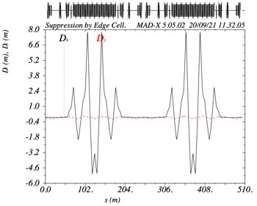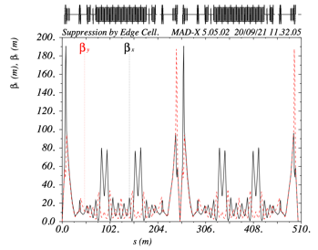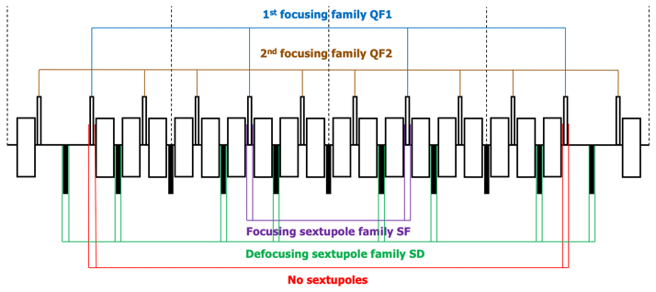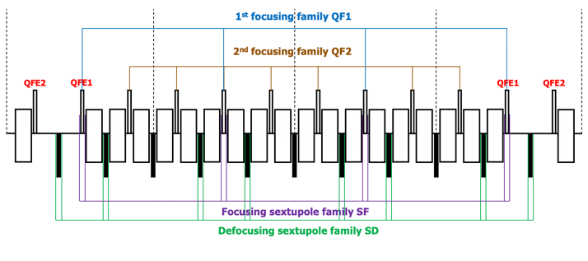Figure 3: Edge Suppressor. Top – principal scheme of arc with edge quadrupoles. Bottom left – $β$-function, bottom right – dispersion function.

Sextupole correction

The tune shift on the arc is equal to $ν_{x arc}=3, ν_{y arc}=3$. Thus, at each superperiod, a tune shift occurs $0,75π$, including the edge ones. In the described case there is peaks of $β$-function on arc at quadrupoles QF2. Thus, the phase difference between the QF2 quadrupoles of the first and third (second and fourth superperiod) is not a multiple of $π/2$. Simultaneously, the number of betatron oscillations between the central quadrupoles (QF1 or QFE1) of 1 and 3 or 2 and 4 superperiods $ν_{1-3}=ν_{2-4}=1,5$. Thus, by placing the sextupoles of the same family next to the central quadrupoles, it will be possible to ensure mutual suppression of the sextupoles.[3]

Dynamic Aperture

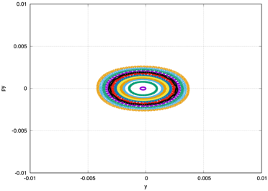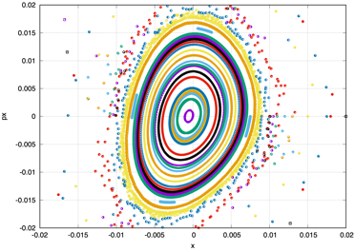Working point for the entire ring $9,44×9,44$, same as for regular structure in heavy ion option. Dynamic aperture on Figure 4 for $dp/p={5×10}^{-3}$ in x-plane: $500 mm×mrad$; in y-plane: $40 mm×mrad$.

Figure 4: Dynamic aperture for edge suppression scheme in both planes for $dp/p={5×10}^{-3}$.

**Arc suppressor**. This case differs from the first, all the quadrupoles of the arc belong to the first or second family, and the suppression of dispersion is also provided by only 2 families. The scheme of arc with $β$-function and dispersion function of all entire ring are shown on Figure 5. But to achieve the required critical energy value, it is necessary to provide a greater modulation of the quadrupole gradients

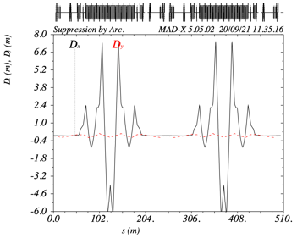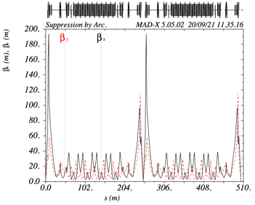Figure 5: Arc Suppressor. Top – principal scheme of arc with only 2 families. Bottom left – $β$-function, bottom right – dispersion function.

than in the case of dispersion suppression by edge superperiods. In this case the phase shift on the arc becomes equal to $ν_{x arc}=2,72, ν_{y arc}=3$.

Sextupole correction

Due to the fact, that tune shift on arc not a multiple of $2π$, and also between the central quadrupoles is not a multiple $π/2$, and is equal to $1,41$, it turns out that the sextupoles do not compensate each other exactly. The arrangement of sextupoles for this case is different from the arrangement of sextupoles in the case of dispersion suppressors at the edges of the arc. The SF family is located next to the central quadrupoles of the superperiod QF1, and SD is located next to the defocusing quadrupoles QD, but only those that surround QF1 on the left and right. However, there are no sextupoles of the focusing family in the edge superperiods. This is done to reduce the influence of sextupoles on the dynamic aperture. The suppression of chromaticity is also possible without them, since the main contribution is made by sextupoles 2 and 3 of the superperiod.

Dynamic Aperture

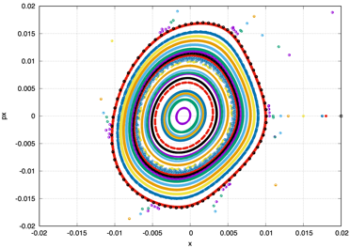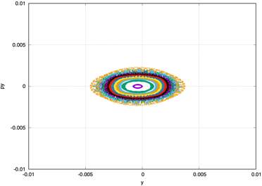The working point for the entire ring is $9,44×9,44$, the same as for the regular structure. Figure 6 shows the dynamic aperture for this working point in both planes for

Figure 6: Dynamic aperture for arc suppression scheme in both planes for $dp/p={5×10}^{-3}$.

$dp/p={5×10}^{-3}$. Dynamic aperture in x-plane: $500 mm×mrad$; in y-plane: $30 mm×mrad$;

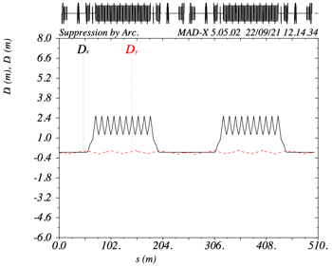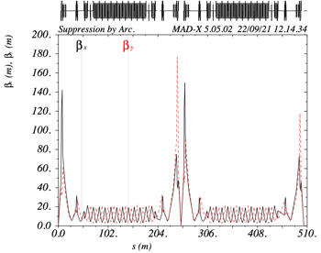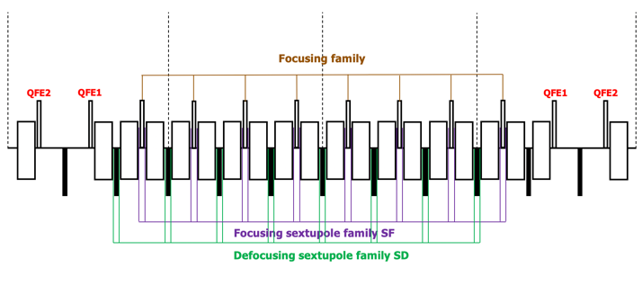 ION MODE

Figure 7: Ion mode. Top – principal scheme of arc with edge quadrupoles. Bottom left – $β$-function, bottom right – dispersion function.

Ion mode structure is regular and have 12 FODO cells and contains 2 families: focusing and defocusing. Dispersion suppressed by two edge FODO cells which have a different focusing quadrupole strength when quadrupole strength in focusing family. The scheme of arc with $β$-function and dispersion function of all entire ring are shown on Figure 7.

Sextupole correction

As structure is regular there is no problems with sextupole correction. Focusing and defocusing sextupoles located near focusing and defocusing quadrupoles in the central cells.

Dynamic Aperture

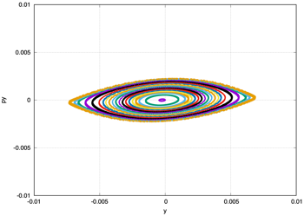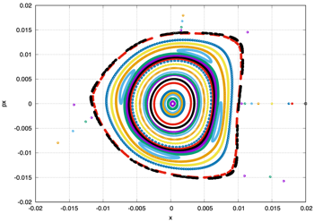Working point for the entire ring $9,44×9,44$, same as for regular structure in heavy ion option. Dynamic aperture on Figure 8 for $dp/p={5×10}^{-3}$ in x-plane: $500 mm×mrad$; in y-plane: $50 mm×mrad$.

Figure 8: Dynamic aperture for ion mode scheme in both planes for $dp/p={5×10}^{-3}$.

CONCLUSION

For proton mode of NICA collider applied method of superperiodic modulation to increase transition energy (change $γ_{tr}$ from $7,1$ to 15). In this case two options of dispersion suppression on the edges of arc can be considered: suppression with edge superperiods and suppression with only two families of quadrupoles. Each option has it is own features, but both of them can be used on NICA collider.

References

[1] Yu. V. Senichev and A. N. Chechenin. Theory of “Resonant” Lattices for Synchrotrons with Negative Momentum Compaction Factor. Journal of Experimental and Theoretical Physics, 2007, Vol. 105, No. 5, pp. 988–997

[2] Yu. V. Senichev and A. N. Chechenin. Construction of “Resonant” Magneto-Optical Lattices with Controlled Momentum Compaction Factor Journal of Experimental and Theoretical Physics, 2007, Vol. 105, No. 6, pp. 1141–1156.

[3] P.J.Bryant, Planning Sextupole Families in a Circular Collider. Advanced accelerator physics. Proceedings, 5th Course of the CERN Accelerator School, Rhodos, Greece, September 20-October 1, 1993. Vol. 1, 2.